

TCP2201 The Myrmidon Chess

Trimester 1, 2018/2019

<<By -- Deep Blue>>

**Team Leader**

WAYILE, JIALADE, 0146865506,[1151102347@student.mmu.edu.my](mailto:1151102347@student.mmu.edu.my)

**Team members**

SAMUEL WONG ING SHIING, 0168706324,[1151103687@student.mmu.edu.my](mailto:1151103687@student.mmu.edu.my)

KEE CHUN WEI,0143273129,[141226751@student.mmu.edu.my](mailto:141226751@student.mmu.edu.my)

AHMAD AMIN BIN ABD RASHID,0172870566,[1141226984@student.mmu.edu.my](mailto:1141226984@student.mmu.edu.my)

**UML DIAGRAM**

Class Diagram

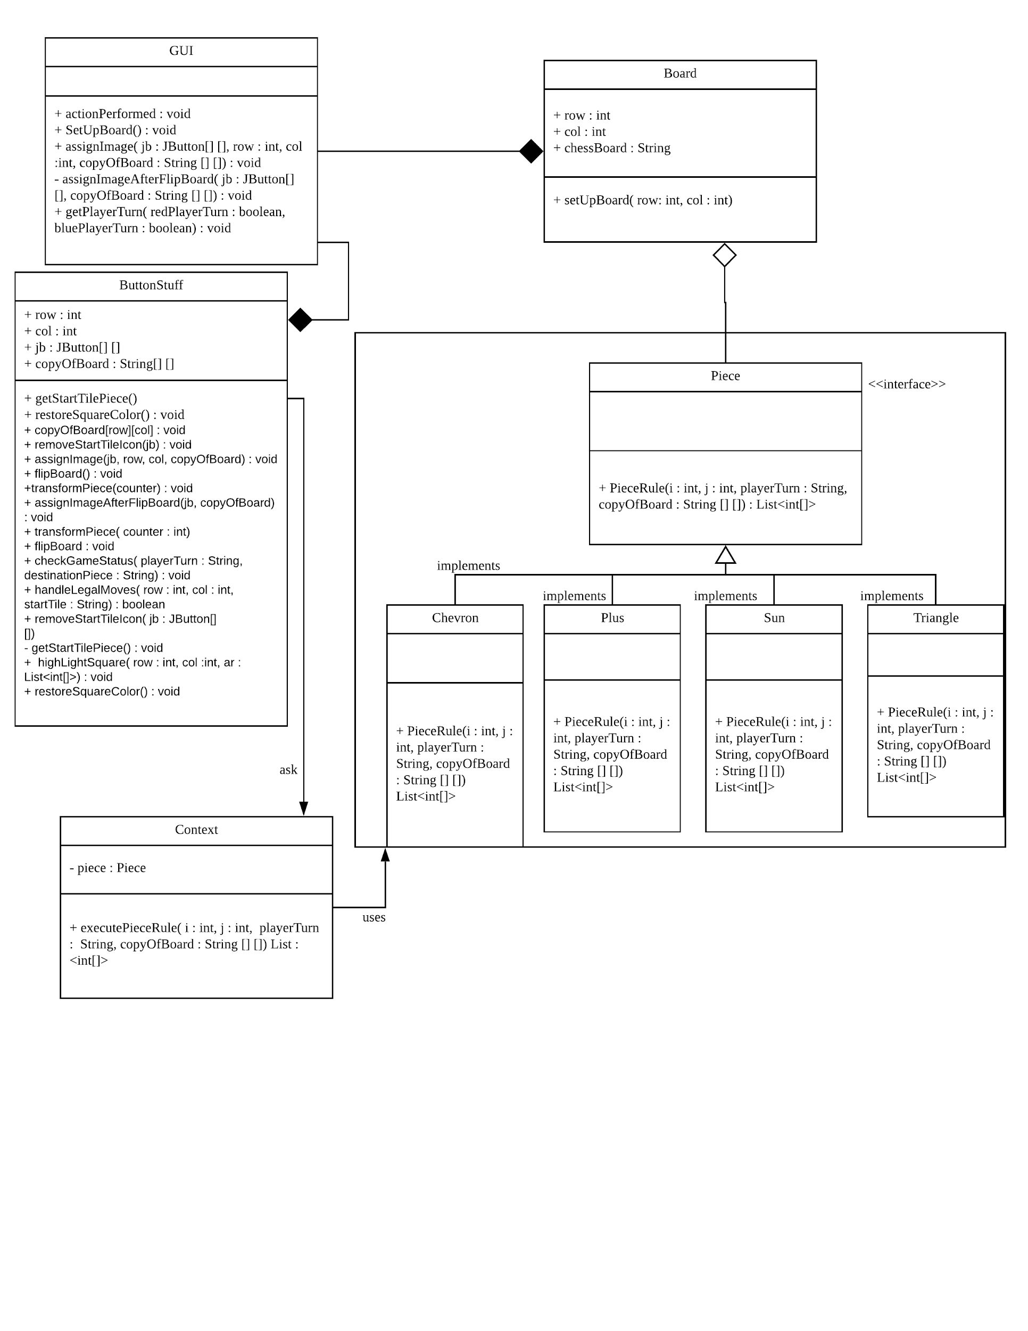

**Sequence Diagram**

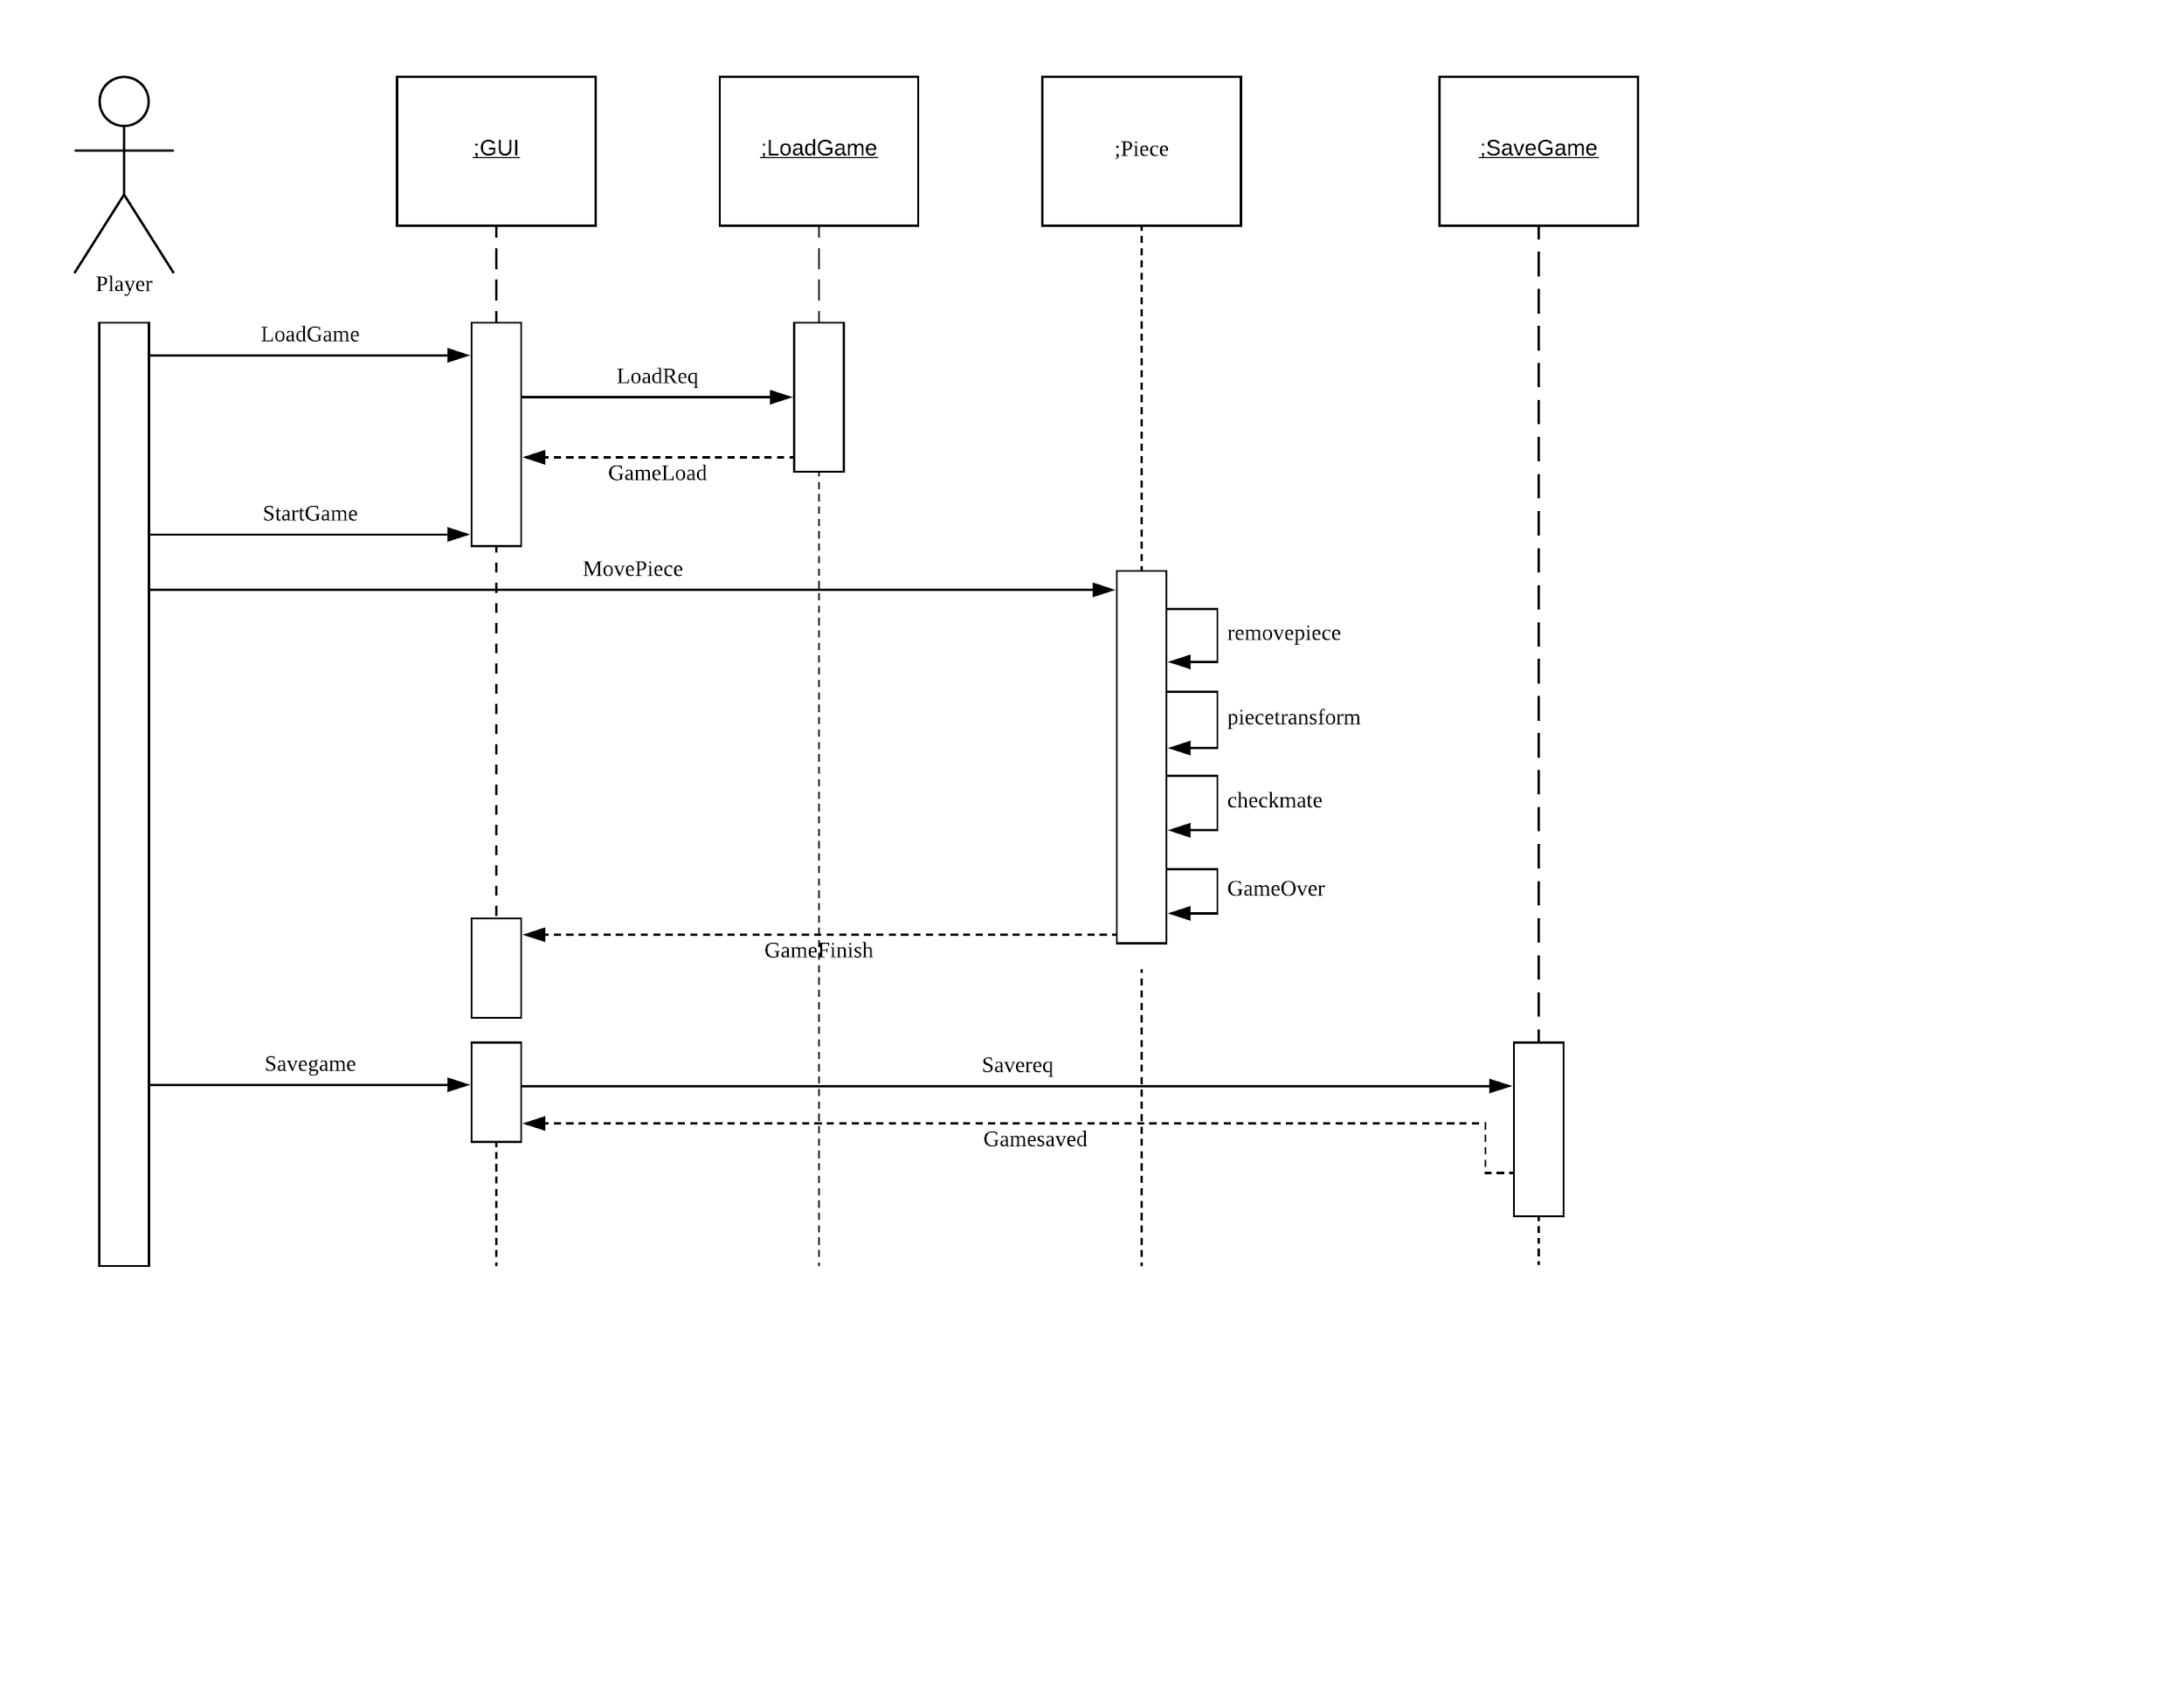

**Use Case Diagram**

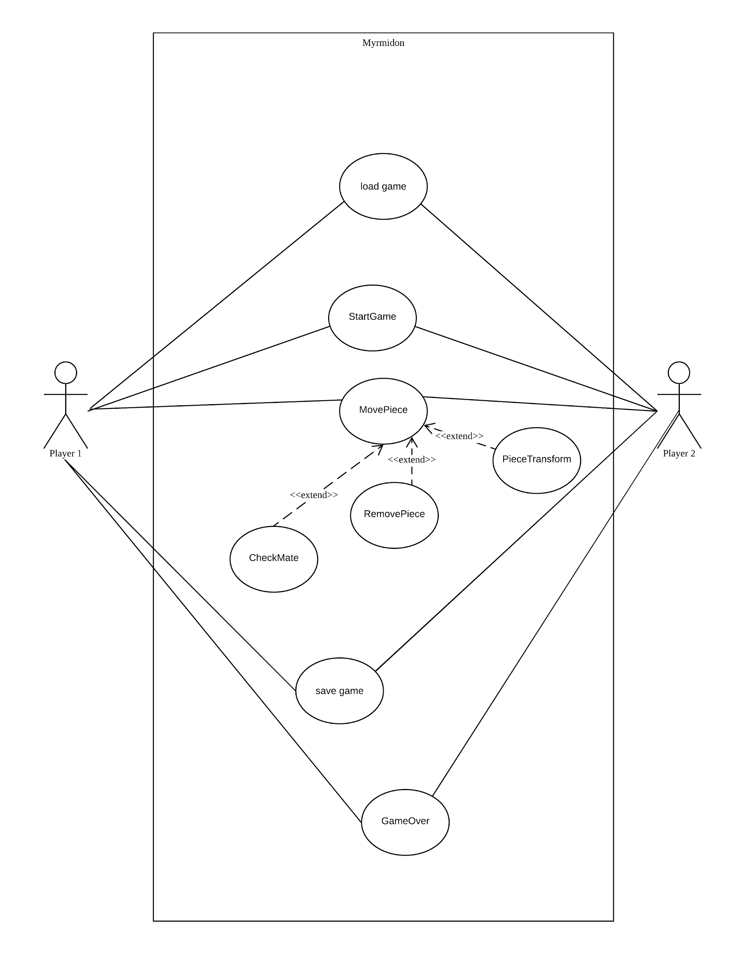

**User Documentation:-**

**Step 1:- Make sure you have the following files in your extracted folder**

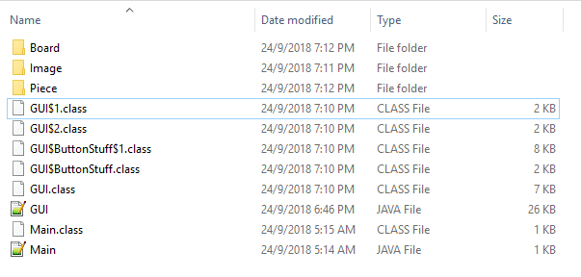

**Step 2:- Open the cmd and move to the folder paths and then type** -> **java Main**

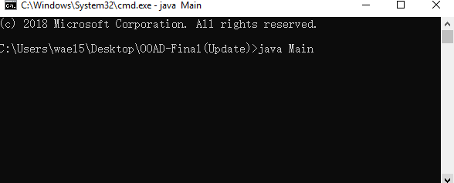

**Step 3 :- Then you will see the game , and you can start playing!**

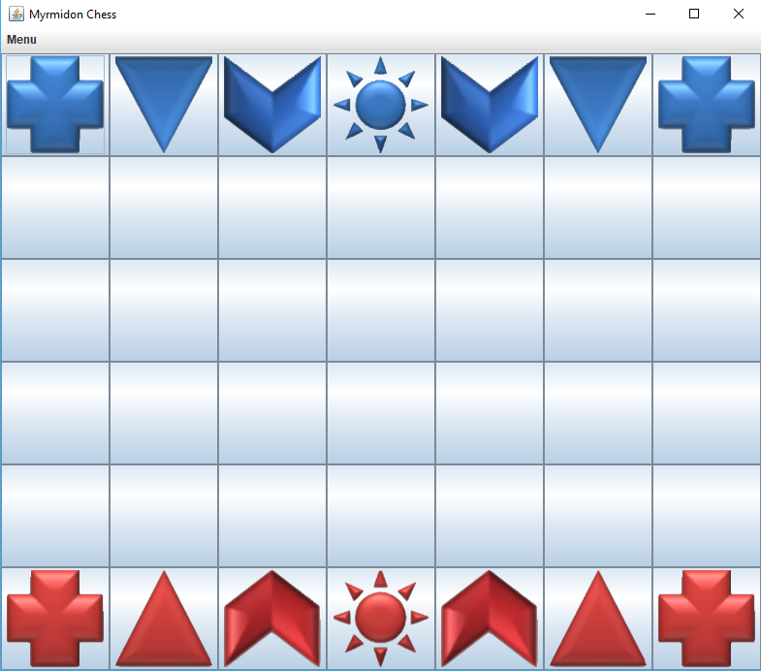

**Step 4:- Understand Piece Play**

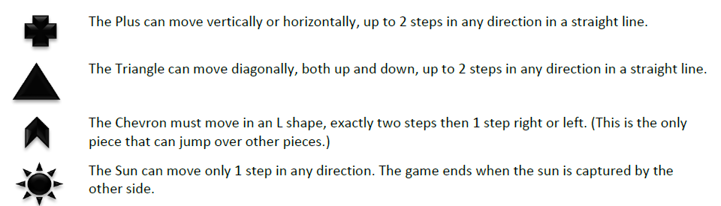

**Step 5:- It is red to play at first, you click a piece and you can see some highlighted squares, those are the squares that your clicked piece can moved in.**

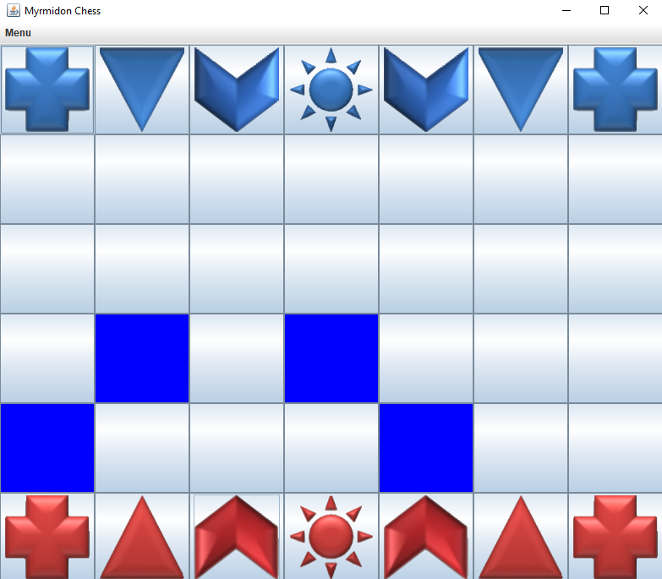

**Step 6: - Click a highlighted square and now its blue turn**

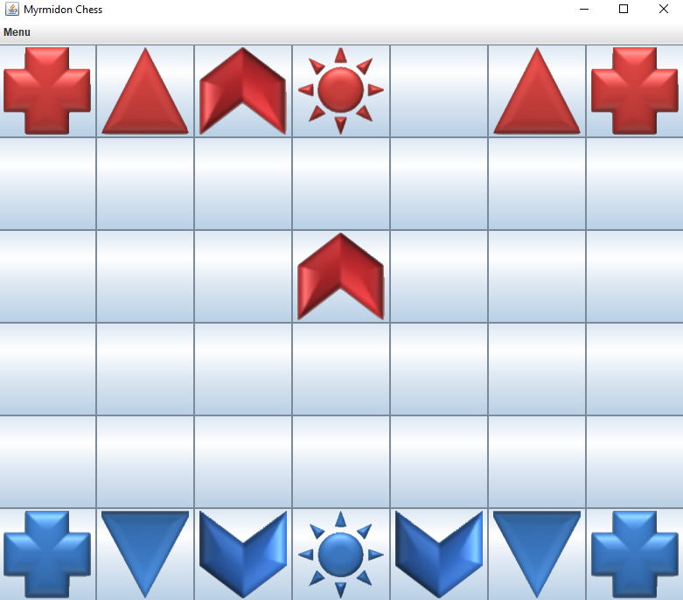

**Step 7:- After 3 turns, a Plus will turn into a Triangle, a Triangle will turn into a Chevron, and a Chevron will turn into a Plus.(Funny part about Myrmidon Chess)**

**Step 8:- You will see a Menu Option at the left top of the program, you can click to save game and a file will be generated on your folder**

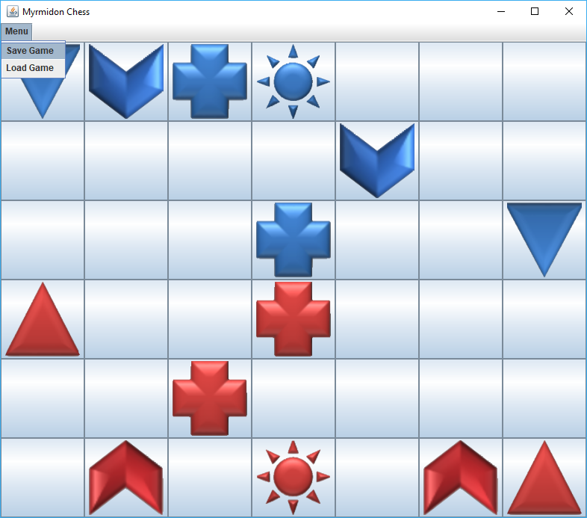

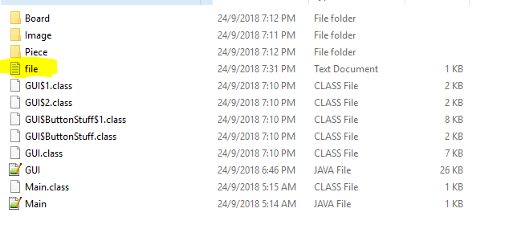

**Step 9 :- Load Game, You can click load game to continue from the position where you save the game**

**Step 10:- After a game finish, you will be notified if you want a new game or not, if you want to play a new game, then you should click Yes, Otherwise you should click No to exit the program.**

